*Management Information System : PROJECT*

*Topic: Reengineering Loan Application Process*

CASE STUDY: LOAN PROCESS APLICATION:

Done by:

BAH Ibrahim

ID: 24771

**INTRODUCTION:**

Malian Bank of Solidarity (French: La Banque malienne de solidarite or BMS-SA ), BMS-SA for short, was established in Bamako, Mali in 2002 through an initiative of President Alpha Oumar Konare. It took on the name BMS-SA in 2003 after the industrial reforms of the country. BMS-SA was among the first international banks to be registered under Malian law in 2007 and got partnerships with others big companies in west African economical zone which is UEMOA compound the countries such as Senegal, Ivory coast, Benin, Togo etc. Fast forward to 2011, BMS-SA merged with Standard and became one of the large financial services institutions in the country. BMS-SA didn't stop there. It expanded, and it reaches beyond Mali, now operating with some worldwide banks like Eco-bank, BECEAO and so on. It boasts over 300 branches at the national level and serves more than 4 million customers. BMS-SA has been a pioneer in many fields, including the first to establish a foundation of AAD-Mali ( ASSOCIATION D’AIDE AU DEVELOPPEMENT), BMS-SA Foundation, among Malian banks in 2011. The bank has earned numerous accolades over the years for its commitment for the development and also its contribution to Malian economic growth. So, there you have it. A bank that had started from humble beginning and grew into a very influential company .

Our project will be based on:

* The problem statements
* Determine the problem’s ecosystem
* System

Process

Stakeholders

Determine the critical -to-quality methods.

Time

Quality

Define the goals and CTQ targets

Draft the business Process Diagram (current state)

The problem statements:

* Registration issues at BMS-SA with clients
* Unqualified staff, manager, Administrator.
* Schedule problems.
* Security of data and digitalization.
* Unclear Eligibility Criteria.
* The problem Ecosystem

The System: is “Loan”

The process start when the customer is in need of money.

Stakeholders: senior management Team of the bank, staff of the bank, customer …

CTQ Measures

CTQ #1: the Time needed to perform the all loan. (TNPL)

CTQ #2: customers Gratification index (CGI)

Process Goals and CTQ Goals

#1. Goals for the process

Plan for TNTL

Weaken TNTL

Provides Better, great and very comfort protection for the CGI

#2 CTQs Goals

. TNTL: 4 weeks

Measures to take:

The time need to process all the loan.

The time need to perform all steps of loan.

Waiting during all the steps of the process.

Measure > The Time needed to perform the loan process.

Method #1

To improve the loan process and increase customer satisfaction, it's essential to identify potential bottlenecks and areas of improvement in Method #1

The duration for each step in the loan process is measured to assess the efficiency and effectiveness of the process.

Loan Record duration for each step.

Measure> customer Gratification index (CGI)

Method: Survey

Write the survey goal to approval the document.

Set that survey goal.

Ask questions to the customer to end the approval the process of loan.

Analyze their responses

Measure> Many customers spend a lot of time to complete their process for the credit agreement to the bank.

Because of methods caused by rules, regulation and the machine cause by equipment, materials cause by the inefficient or defect, management caused by the improper management and people cause by lack of personnel qualified.

Our target will be to reduce the total time to 12 days.

**CURRENT PROCESS:**

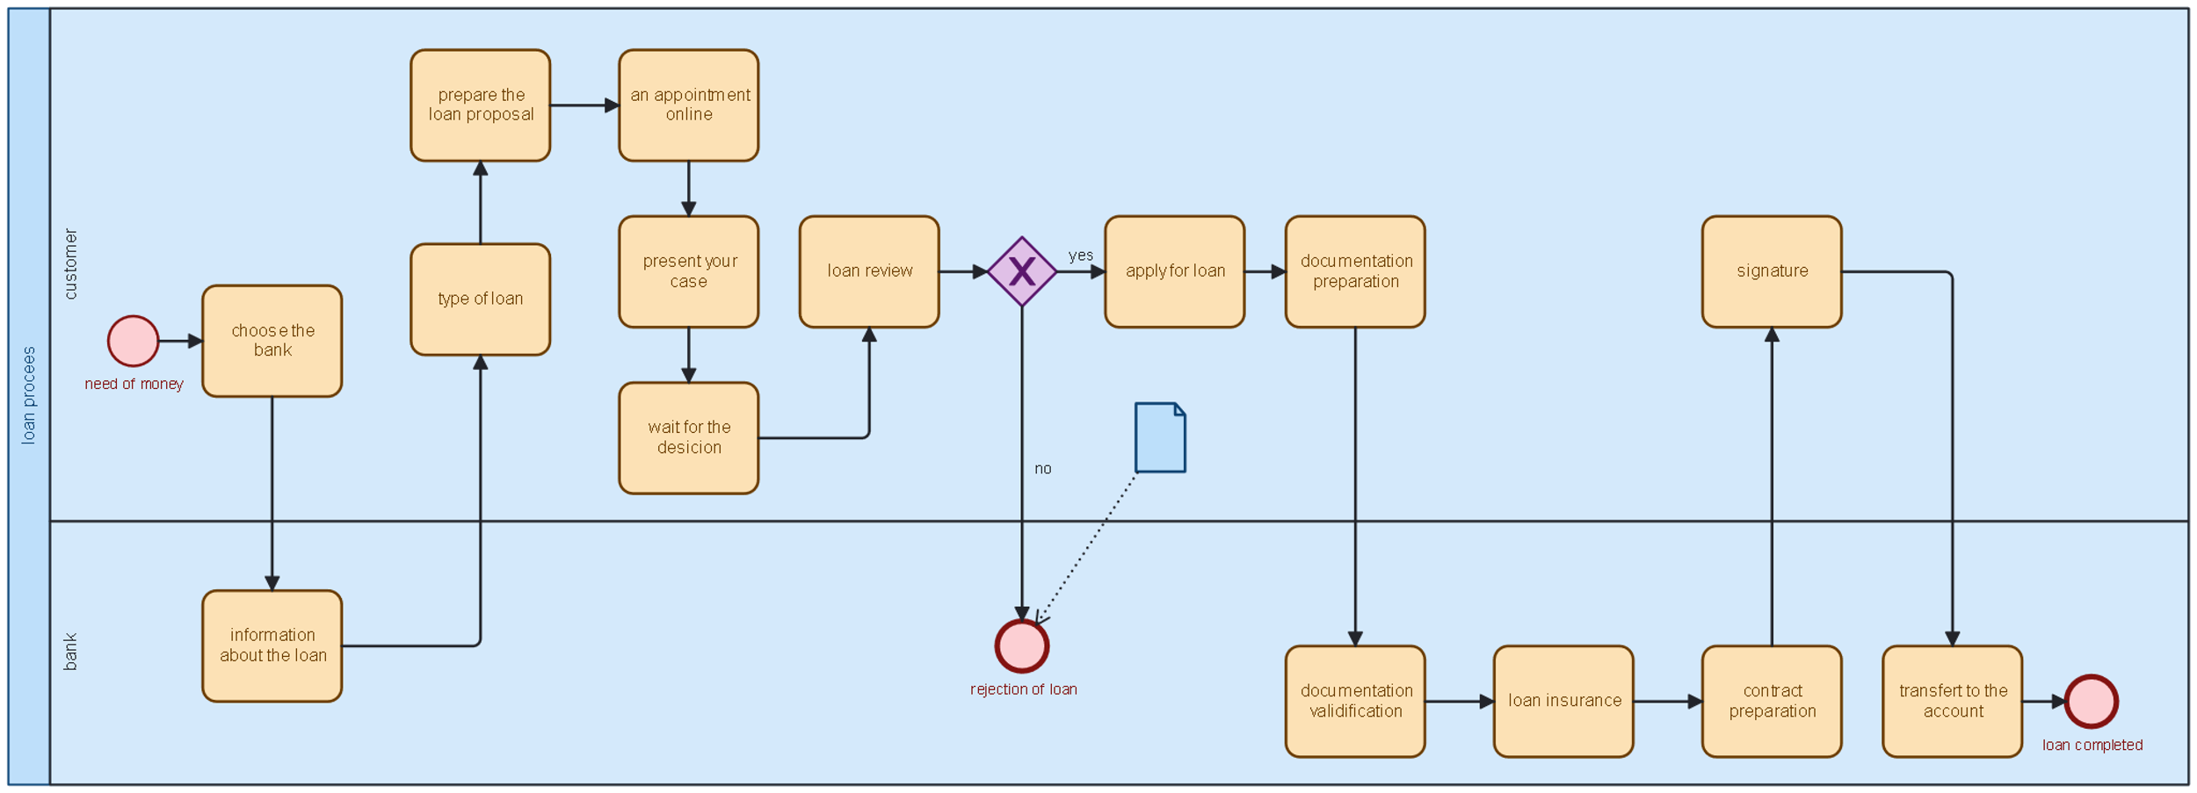

|  |  |  |
| --- | --- | --- |
| # | STEPS | TIME |
| 1 Activity | Choose the bank | 6 minutes |
| 2 Activity | Information about the loan | 6 minutes |
| 3 Activity | Type of loan | 2 minutes |
| 4 waiting | Prepare a loan proposal | 8 minutes |
| 5 Activity | An appointment or apply online | 25 minutes |
| 6 waiting | Ask question | 15 minutes |
| 7 Waiting | Present your case | 9 minutes |
| 8 Waiting | Wait for the decision | 3 weeks |
| 9 Activity | Loan review | 23 minutes |
| 10 Activity | Apply for the loan | 1 day |
| 11 Activity | Documentation preparation | 2 days |
| 12 Activity | Validation | 3 days |
| 13 Activity | Loan assurance | 3 day |
| 14 waiting | Contract preparation | 3 days |
| 15 Activity | Signature | 7 minutes |
| 16 Activity | Transfer to account | 15 minutes |
| TOTAL |  | 1 month and 2 days and 1hours 56 minutes |

|  |  |  |
| --- | --- | --- |
|  | steps | time |
| 1. Activity | Choose the bank | 2 minutes |
| 1. Activity | Information about the loan | 4 minutes |
| 1. Activity | Type of loan | 2 minutes |
| 1. waiting | Prepare a loan proposal | 5 minutes |
| 1. Activity | An appointment or apply online | 10 minutes |
| 1. waiting | Ask question and present your case | 20 minutes |
| 1. Activity | Apply for the loan | 20 minutes |
| 1. Waiting | Wait for the decision | 5 days |
| 1. Activity | Documentation preparation | 10 hours |
| 1. Activity | Validation | 2 days |
| 1. Activity | Loan Assurance | 15 hours |
| 1. Activity | Contract preparation | 1 days |
| 1. Activity | signature | 3 minutes |
| 1. Activity | Transfer to account | 5 minutes |
| Total 9 days 1 hours and 8 minutes | | | |

**AFTER PROCESSING**: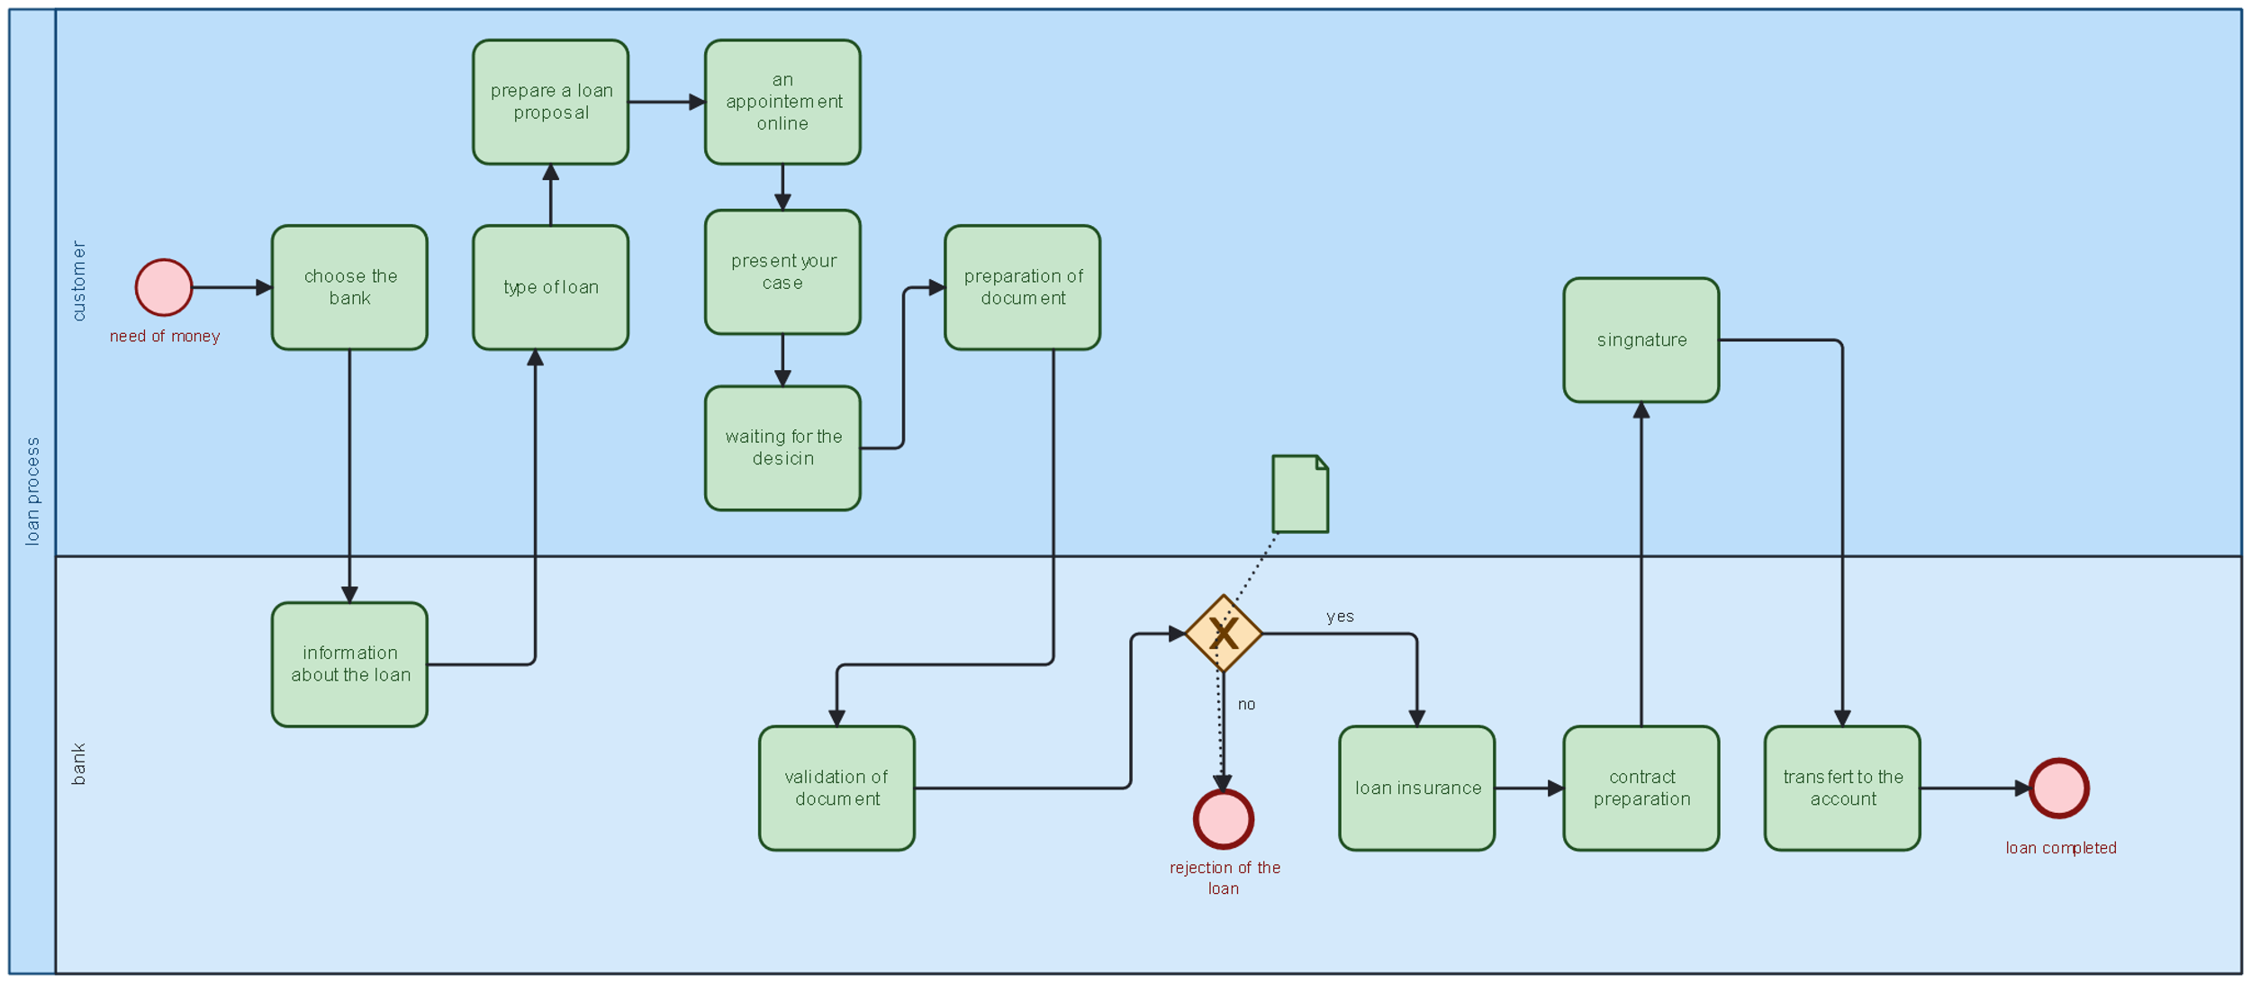

**Conclusion:**

In light of the challenges faced by customers experiencing delays in the loan process, our team of MIS students has been dedicated to finding innovative solutions to streamline and expedite the process for the benefit of both customers and the bank. After careful analysis and consideration, we are thrilled to present a cutting-edge, efficient, and user-friendly loan system. By harnessing the power of technology and data-driven insights, our new and improved system aims to revolutionize the loan process, empowering customers with faster access to funds while enhancing the bank's operations and overall customer satisfaction. With this transformative solution, we envision a future where obtaining a loan becomes a seamless and hassle-free experience, contributing to the financial well-being of countless individuals and businesses alike. Together, let us embrace this new era of lending possibilities and propel the banking industry into a brighter, more prosperous tomorrow.